24CSI024-DATA STRUCTURES AND ALGORITHMS UNIT 1-INTRODUCTION TO DATA STRUCTURES AND ALGORITHMS
Arrays and Array-Based Techniques (Two-Pointer, Sliding Window, Prefix Sums)
LAB WORKBOOK-16.07.2026

CATEGORY: EASY

Question 1: Merging Two Sensor Logs (Two-Pointer)
Two weather stations, A and B, each recorded temperature readings independently and stored them in non-decreasing sorted order. Divya needs to merge both logs into a single sorted array for her analysis dashboard — without using any built-in sort function, and in O(N + M) time.
She uses the two-pointer merge technique:
- Initialize a pointer i at index 0 of array A and a pointer j at index 0 of array B.
- Compare A[i] and B[j]. Copy the smaller value into the output array and advance that pointer.
- Repeat until one array is exhausted.
- Copy any remaining elements of the other array directly into the output.
10 | 2 2  0 0  -1 4
5 8 9 10 | -1 0 0 4
- The first line of input consists of two space-separated integers N and M — the sizes of arrays A and B.
- The second line consists of N space-separated integers (array A, sorted).
- The third line consists of M space-separated integers (array B, sorted).
- Print a single line of N + M space-separated integers representing the merged sorted array.
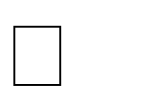

- 1  N, M  10000



-  10⁴  arr[i]  10⁴

Input 1: Input 2:

9
8
Output: Output:

3
AIM:
To merge two sorted arrays into a single sorted array using the Two-Pointer Technique in O(N + M) time without using any built-in sorting function.
PSEDUO CODE:
void mergeSortedArrays(int A[], int B[], int C[], int N, int M)
{
int i = 0,j=0,k=0;
while (i<N&&j<M)
{
if (A[i]<=B[j])
{
C[k]=A[i];
i++;
}
else
{
C[k] = B[j];
j++;
}
k++;
}
while (i<N)
{
C[k]=A[i];
i++;
k++;
}
while (j<M)
{
C[k]=B[j];
j++;
k++;
}
}
C CODE:
#include <stdio.h>
int main()
{
int n,m;
scanf("%d%d",&n,&m);
int a[n],b[m];
int c[n+m];
for(int i=0;i<n;i++)
{
scanf("%d",&a[i]);
}
for(int i=0;i<m;i++)
{
scanf("%d",&b[i]);
}

int i=0,j=0,k=0;
while(i<n && j<m)
{
if(a[i]<=b[j])
{
c[k]=a[i];
i++;
}
else
{
c[k]=b[j];
j++;
}
k++;
}
while(i<n)
{
c[k]=a[i];
i++;
k++;
}
while(j<m)
{
c[k]=b[j];
j++;
k++;
}
for(i=0;i<n+m;i++)
{
printf("%d ",c[i]);
}
return 0;
}
OUTPUT:
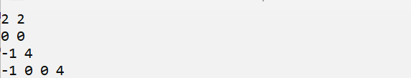
RESULT:
Thus the above program successfully sorted the two arrays and were merged into a single sorted array using the Two-Pointer Technique

Question 2: Locating the First Below-Threshold Reading (Linear Search)
Farhan monitors battery voltage readings from a fleet of IoT sensors, logged in
the order they were received (not sorted). He needs to find the position of the first reading that drops below a safe voltage threshold T, so maintenance can pinpoint when the fault began.
- The first line of input consists of two space-separated integers N and T.
- The second line consists of N space-separated integers representing the voltage readings, in the order recorded.

- Print a single integer: the 0-indexed position of the first reading strictly less than T. If no such reading exists, print -1.


- 1  N  10000



-  10³  arr[i], T  10³

Input 1: Input 2:

6 5  9 7 6 4 8 3 | 4 0  1 2 3 4
Output: |  | Output:
3 | -1

AIM:
To find the first position of the element that is strictly less than the given threshold value (T) using the Linear Search technique.
PSEUDO CODE:
int firstBelowThreshold(int arr[], int N, int T)
{
for(int i = 0; i < N; i++)
{
if(arr[i] < T)
{
return i;
}
}
return -1;
}
C CODE:
#include <stdio.h>
int main()
{
int n, t;
scanf("%d%d", &n, &t);
int arr[n];
for(int i=0;i<n;i++)
{
scanf("%d",&arr[i]);
}
for(int i=0;i<n;i++)
{
if(arr[i]<t)
{
printf("%d",i);
return 0;
}
}
printf("-1");
return 0;
}
OUTPUT:
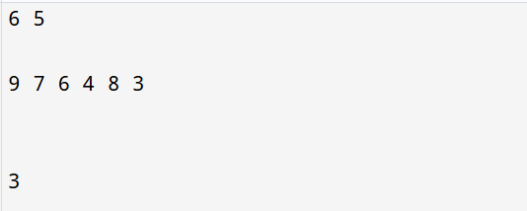
RESULT:
Thus the above program found the first position of the element that is strictly less than the given threshold value (T) using the Linear Search technique.

CATEGORY: MEDIUM

Question 3: Maximum Rainwater Between Towers (Two-Pointer)
A telecom company has N transmission towers of varying heights standing in a row. During heavy rain, water can collect in the “well” formed between two towers, bounded by the shorter of the two. Meera wants to find the two towers that can trap the maximum volume of water between them, so she can plan drainage.
She solves it in O(N) using two pointers instead of checking every pair:
- Initialize left = 0 and right = N - 1, and maxWater = 0.
- Compute the water trapped between left and right: min(height[left], height[right]) * (right - left). Update maxWater if this is larger.
- Move the pointer at the shorter tower inward — it can never form a better pair with anything closer than the taller side already offers.
- Repeat until left meets right.
  - The first line of input consists of an integer N — the number of towers.
  - The second line consists of N space-separated non-negative integers representing tower heights.
  - Print a single integer representing the maximum water that can be trapped, in the format: Max Water: X.


  - 2  N  10000


  - 0  height[i]  10⁴

Input 1: Input 2:

2 5 4 8 3 7 | 4  1 1 1 1

6

Output: Output:
Max Water: 49 | Max Water: 3

AIM:
To find the maximum amount of water that can be trapped between two towers using the Two-Pointer Technique.
PSEDUO CODE:
int maxWater(int height[], int N)
{
int left = 0;
int right = N - 1;
int maxWater = 0;
while(left < right)
{
int width = right - left;
int water;
if(height[left] < height[right])
water = height[left] * width;
else
water = height[right] * width;
if(water > maxWater)
maxWater = water;
if(height[left] < height[right])
left++;
else
right--;
}
return maxWater;
}
C CODE:
#include <stdio.h>
int main()
{
int n;
scanf("%d",&n);
int height[n];
int i;
for(i=0;i<n;i++)
{
scanf("%d",&height[i]);
}
int left=0;
int right=n-1;
int maxWater=0;
while(left<right)
{
int width=right-left;
int water;

if(height[left]<height[right])
water=height[left]*width;
else
water=height[right]*width;

if(water>maxWater)
maxWater=water;

if(height[left]<height[right])
left++;
else
right--;
}
printf("Max Water: %d",maxWater);
return 0;
}

OUTPUT:
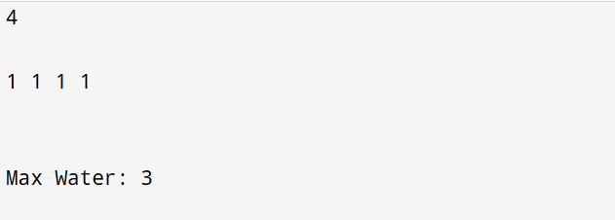
RESULT:
Thus the above program found the maximum amount of water that can be trapped between two towers using the Two-Pointer Technique.

Question 4: Finding the Insertion Point for a New Calibration Value (Binary Search)
A lab keeps a sorted array of calibration reference values. Whenever a new value arrives, Ibrahim needs to find the exact index where it should be inserted to keep the array sorted — without scanning the whole array.
He uses a binary search variant that finds the first index whose value is greater than or equal to the new value:
- Initialize low = 0, high = N.
- While low < high: compute mid = low + (high - low) / 2.
- If arr[mid] < target, set low = mid + 1. Otherwise, set high = mid.
- When the loop ends, low is the correct insertion index.
- The first line of input consists of two space-separated integers N and target.
- The second line consists of N space-separated integers in non-decreasing order.
- Print a single integer: the index at which target should be inserted, in the format: Insert At: X.


- 1  N  10000



-  10⁴  arr[i], target  10⁴

Input 1: Input 2:

6 29 | 4 5  1 2 3 4
10 20 30 40 50 60
Output: Output:

Insert At: 2 | Insert At: 4

AIM:

To find the correct position to insert a new element in a sorted array using Binary Search.

PSEDUO CODE:
int findInsertPosition(int arr[], int N, int target)
{
int low = 0;
int high = N;
while(low < high)
{
int mid = (low + high) / 2;
if(arr[mid] < target)
low = mid + 1;
else
high = mid;
}
return low;
}
C CODE:
#include <stdio.h>

int main()
{
int n,target;
scanf("%d%d",&n,&target);
int arr[n];
for(int i=0;i<n;i++)
{
scanf("%d",&arr[i]);
}
int low=0,high = n;
while(low<high)
{
int mid=low+(high-low)/2;

if(arr[mid]<target)
low=mid+1;
else
high=mid;
}
printf("Insert At: %d",low);
return 0;
}

OUTPUT:
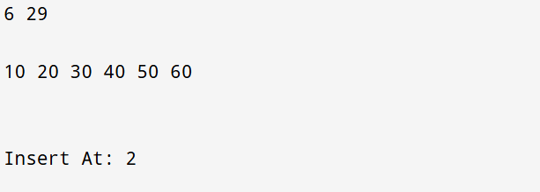
RESULT:

Thus the above program founds the correct position to insert a new element in a sorted array using Binary Search.

CATEGORY: HARD

Question 5: Locating a Packet in a Rotated Log Buffer (Modified Binary Search)
A circular network buffer stores log entries sorted by timestamp, but because it wraps around, the array as read out is a rotated sorted array (e.g., the oldest entries appear after the newest due to the wraparound point). Sana needs to locate a specific timestamp T in O(log N) time — a plain binary search won’t work directly since the array isn’t fully sorted end-to-end.
She adapts binary search to handle the rotation:
- Initialize low = 0, high = N - 1.
- Compute mid. If arr[mid] == target, return mid.
- Determine which half (low to mid, or mid to high) is properly sorted by comparing arr[low] and arr[mid].
- Check if target lies within the value range of the sorted half. If it does, recurse/iterate into that half; otherwise, search the other half.
- Repeat until found or the range is empty.
- The first line of input consists of two space-separated integers N and target.

- The second line consists of N space-separated distinct integers representing the rotated sorted array.
- Print a single integer: the 0-indexed position of target in the array, in the format: Found At: X. If not present, print Found At: -1.


- 1  N  10000



-  10⁵  arr[i], target  10⁵
- The array is a sorted array rotated at some unknown pivot; all elements are distinct.

Input 1: Input 2:

7 0  4 5 6 7 0 1 2 | 5 3  4 5 6 7 8
Output: | Output:
Found At: 4 | Found At: -1

AIM:

To find the position of a target element in a rotated sorted array using Modified Binary Search.

PSEDUO CODE:
int searchRotatedArray(int arr[], int N, int target)
{
int low = 0;
int high = N - 1;
while(low <= high)
{
int mid = (low + high) / 2;
if(arr[mid] == target)
return mid;
if(arr[low] <= arr[mid])
{
if(target >= arr[low] && target < arr[mid])
high = mid - 1;
else
low = mid + 1;
}
else

{
if(target > arr[mid] && target <= arr[high])
low = mid + 1;
else
high = mid - 1;
}
}

return -1;
}
C CODE:
#include <stdio.h>
int main()
{
int n,target;
scanf("%d%d",&n,&target);
int arr[n];
for(int i=0;i<n;i++)
{
scanf("%d",&arr[i]);
}
int low=0;
int high=n-1;
while(low<=high)
{
int mid=low+(high-low)/2;
if(arr[mid]==target)
{
printf("Found At: %d",mid);
return 0;
}
if(arr[low]<=arr[mid])
{
if(target>=arr[low]&&target<arr[mid])
high=mid-1;
else
low=mid+1;
}
else
{
if(target>arr[mid]&&target<=arr[high])
low=mid+1;
else
high=mid-1;
}
}
printf("Found At: -1");
return 0;
}
OUTPUT:
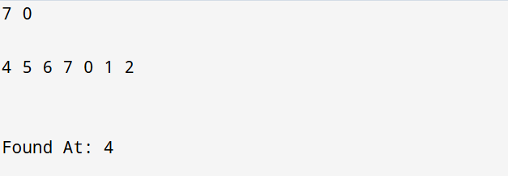
RESULT:
Thus the above program found the position of a target element in a rotated sorted array using Modified Binary Search.

VIVA QUESTIONS:
- “In binary search, why must the array be sorted before we can safely discard half the search space at each step? What breaks if it isn’t?”
ANSWER:
- Binary search works only on a sorted array because it decides whether to search the left half or the right half.
- If the array is not sorted, this decision will be wrong, and the required element may not be found.
- “Contrast the worst-case and best-case time complexity of linear search. Under what real-world circumstance would linear search actually outperform binary search on the same data?”
ANSWER:
- Best Case: O(1) – The element is found at the first position.
- Worst Case: O(N) – The element is at the last position or not present.
- Linear search can be faster for small or unsorted arrays because it does not require sorting.

- “In the rotated sorted array search problem, why can’t we simply check if arr[mid] < target the way we would in a standard binary search? What extra information do we need at each step?”
ANSWER:
A rotated array is not completely sorted. We must first identify which half of the array is sorted, then check whether the target lies in that half.

- “The two-pointer merge technique for two sorted arrays runs in O(N+M) time. Why would sorting the concatenation of both arrays from scratch be a worse approach, even though both are technically valid?”
ANSWER:
The two-pointer method merges the arrays in O(N + M) time, while sorting the combined array takes O((N + M) log(N + M)) time. Therefore, the two-pointer method is faster.
- “In the ‘maximum rainwater between towers’ problem, why is it always safe to move the pointer at the shorter tower inward, and never the taller one?”
ANSWER:
The shorter tower limits the amount of water that can be stored. Moving the shorter pointer may find a taller tower and increase the water trapped.

- “low + (high - low) / 2 is preferred over (low + high) / 2 for computing the midpoint in binary search. What specific failure does this guard against, and under what conditions would that failure actually occur in C?”
ANSWER:
It prevents integer overflow when low and high are very large. Hence, it is the safer way to calculate the middle index.

- “If you were asked to implement binary search recursively instead of iteratively in C, what trade-off would you be making in terms of memory, and why does this matter for embedded systems with limited stack size?”
ANSWER:
Recursive binary search uses extra stack memory for function calls, while iterative binary search uses less memory. Therefore, the iterative method is preferred for systems with limited memory.

- “How would you modify binary search to find the last occurrence of a repeated value in a sorted array, rather than just any occurrence?”
ANSWER:
When the target is found, store its index and continue searching towards the right side to find the last occurrence.

- “Explain why the two-pointer technique for merging arrays cannot be applied directly if one of the arrays is unsorted. What would need to change?”
ANSWER:
The two-pointer technique works only when both arrays are sorted. If one array is unsorted, it must be sorted first before merging.

- “In terms of cache behavior, why might linear search on a small array sometimes run faster in practice than binary search, despite having worse asymptotic complexity?”
ANSWER:
For small arrays, linear search checks elements one by one with very little overhead. Therefore, it can sometimes be faster than binary search in practice.

